Before running this test code, you will need to first create a CustomStringMethods object named "methods"

**TEST CODE for alphabetical method**

methods.alphabetical("apple", "banana");

methods.alphabetical("banana", "apple");

methods.alphabetical("apple", "apple");

**EXPECTED OUTPUT:**

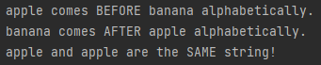

**TEST CODE for halvesReversed method**

String str = methods.halvesReversed("computer"); //even # of letters

System.out.println(str);

str = methods.halvesReversed("computers"); //odd # of letters

System.out.println(str);

str = methods.halvesReversed("sky");

System.out.println(str);

str = methods.halvesReversed("weekend");

System.out.println(str);

str = methods.halvesReversed("an");

System.out.println(str);

str = methods.halvesReversed("I");

System.out.println(str);

str = methods.halvesReversed("see you soon");

System.out.println(str);

str = methods.halvesReversed("see you later!");

System.out.println(str);

**EXPECTED OUTPUT:**

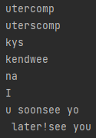

**TEST CODE for yellOrWhisper method**

String str = methods.yellOrWhisper("Hello James!");

System.out.println(str);

str = methods.yellOrWhisper("hello James!");

System.out.println(str);

str = methods.yellOrWhisper("aBCDEFGHIJK");

System.out.println(str);

str = methods.yellOrWhisper("Abcdefghijk");

System.out.println(str);

str = methods.yellOrWhisper("B");

System.out.println(str);

str = methods.yellOrWhisper("b");

System.out.println(str);

str = methods.yellOrWhisper("IT'S SUNNY!");

System.out.println(str);

str = methods.yellOrWhisper("it's rainy");

System.out.println(str);

**EXPECTED OUTPUT:**

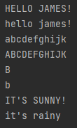

**TEST CODE for** **endUp** **method**

String str = methods.endUp("It's Thursday", 3);

System.out.println(str);

str = methods.endUp("hello friend", 3);

System.out.println(str);

str = methods.endUp("hello friend!", 3);

System.out.println(str);

str = methods.endUp("Shhhh! Be quiet", 3);

System.out.println(str);

str = methods.endUp("Yes", 3);

System.out.println(str);

str = methods.endUp("Yess", 3);

System.out.println(str);

str = methods.endUp("Yesss", 3);

System.out.println(str);

str = methods.endUp("no", 3);

System.out.println(str);

str = methods.endUp("no!", 3);

System.out.println(str);

str = methods.endUp("noo!", 3);

System.out.println(str);

str = methods.endUp("noo!!", 3);

System.out.println(str);

str = methods.endUp("ALREADY UPPERCASE", 3);

System.out.println(str);

str = methods.endUp("hello friend", 1);

System.out.println(str);

str = methods.endUp("hello friend", 6);

System.out.println(str);

str = methods.endUp("hello friend", 20);

System.out.println(str);

**EXPECTED OUTPUT:**

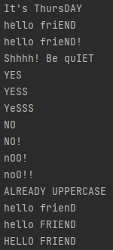

**TEST CODE for removeCharacter method**

String str = methods.removeCharacter("Halloween", 5);

System.out.println(str);

str = methods.removeCharacter("Halloween", 0);

System.out.println(str);

str = methods.removeCharacter("Halloween", 8);

System.out.println(str);

str = methods.removeCharacter("Halloween", 9);

System.out.println(str);

str = methods.removeCharacter("Halloween", 20);

System.out.println(str);

str = methods.removeCharacter("Hi friend", 0);

System.out.println(str);

str = methods.removeCharacter("Hi friend", 1);

System.out.println(str);

str = methods.removeCharacter("Hi friend", 2);

System.out.println(str);

str = methods.removeCharacter(" Hi friend", 0);

System.out.println(str);

str = methods.removeCharacter("A", 0);

System.out.println(str);

str = methods.removeCharacter("A ", 0);

System.out.println(str);

str = methods.removeCharacter("A", 1);

System.out.println(str);

str = methods.removeCharacter("A ", 1);

System.out.println(str);

**EXPECTED OUTPUT:**

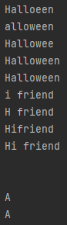

(original string)

(original string)

**.←**(empty string)

**.←**(a space!)

(original string)

(space after the A removed)

**TEST CODE for insertAt method**

String str = methods.insertAt("ghost", "BOO!", "o");

System.out.println(str);

str = methods.insertAt("ghost", "BOO!", "st");

System.out.println(str);

str = methods.insertAt("ghost", "BOO!", "m");

System.out.println(str);

str = methods.insertAt("spooooky!", "YIKES", "o");

System.out.println(str);

str = methods.insertAt("happy birthday!", "18th", "y");

System.out.println(str);

str = methods.insertAt("happy birthday!", "18th", "birthday");

System.out.println(str);

str = methods.insertAt("happy birthday!", "18th", " ");

System.out.println(str);

str = methods.insertAt("happy birthday!", " 18th", " ");

System.out.println(str);

str = methods.insertAt("happy birthday!", "18th ", "bir");

System.out.println(str);

str = methods.insertAt("happy birthday!", "18th", "!");

System.out.println(str);

str = methods.insertAt("happy birthday!", "18th", "z");

System.out.println(str);

str = methods.insertAt("a", "m", "a");

System.out.println(str);

str = methods.insertAt("a", "m", "p");

System.out.println(str);

**EXPECTED OUTPUT:**

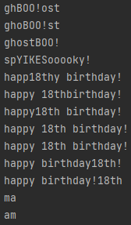

(m not found)

(inserts at *first* o)

(inserts at *first* y)

(z not found)

(p not found)